UNIVERSITY OF ENGINEERING AND TECHNOLOGY MARDAN


Data Mining Lab: 02
Muhammad Ismail
23MDBCS415
Department: CS (Data Science)
6th Semester

Weka Installation

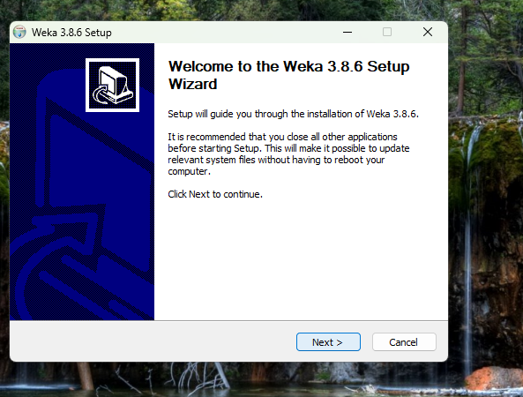
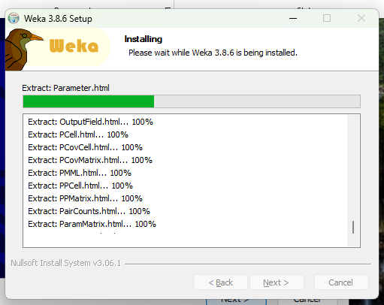



Iris Dataset Upload
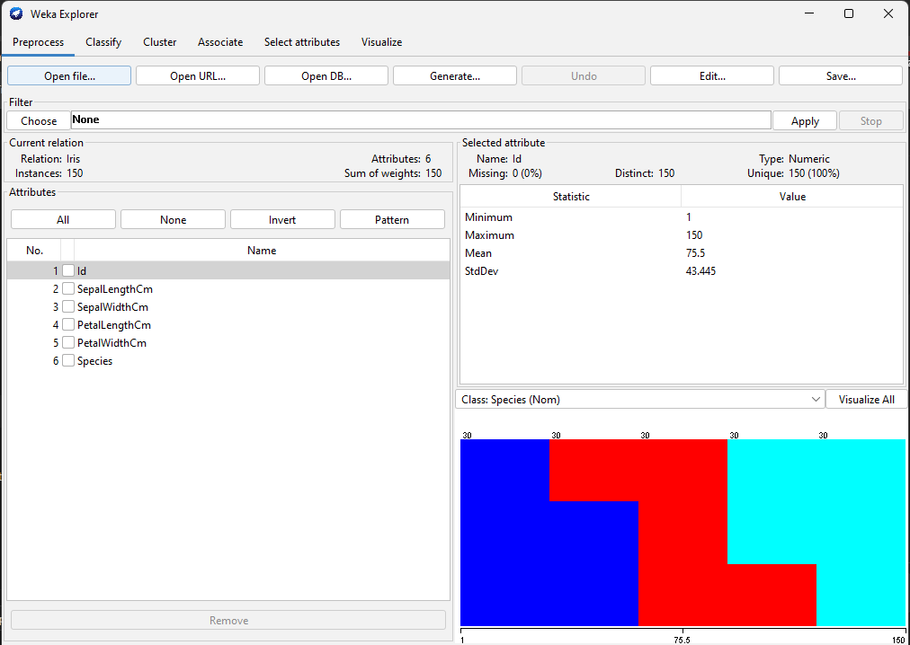

Filter Apply
1.
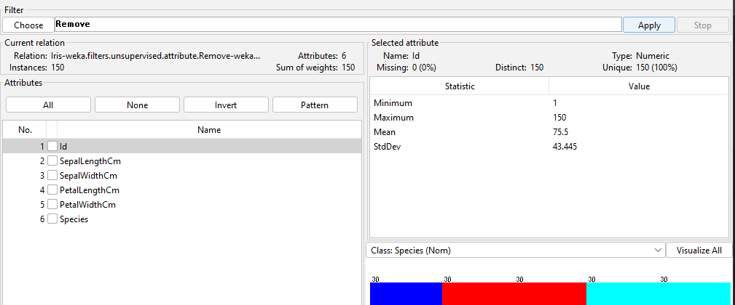
2.
Discretize Filter
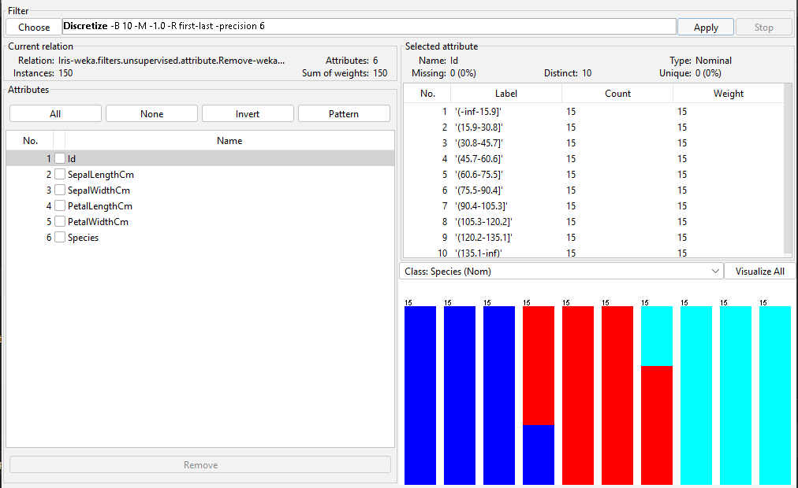

Short Explanation:

Data mining is the process of extracting meaningful patterns and knowledge from large datasets. In this lab, WEKA software was used to explore dataset preprocessing and filtering techniques. WEKA is a popular open-source data mining tool developed by the University of Waikato.
The objective of this lab was to:
- Install WEKA
- Load a dataset
- Apply preprocessing filters
- Understand how data is prepared before modeling

Software Installation
WEKA was downloaded from the official website and installed successfully. After installation, the Weka GUI Chooser window was opened. The “Explorer” interface was selected for performing data preprocessing tasks.
The installation screenshot is attached in the submission.

Dataset Loading
For this experiment, the built-in dataset weather.nominal.arff was used. The dataset contains weather conditions and a decision attribute indicating whether to play or not.
Steps followed:
- Opened Weka Explorer.
- Navigated to the Preprocess tab.
- Clicked “Open file”.
- Selected weather.nominal.arff dataset.
After loading, the dataset summary showed:
- Number of instances: 14
- Number of attributes: 5
- Attributes: outlook, temperature, humidity, windy, play
The dataset loading screenshot is attached.

Data Preprocessing and Filtering
Data preprocessing is an important step in data mining. It improves data quality and ensures better model performance.
1. Remove Filter
The Remove filter was applied to delete the “temperature” attribute from the dataset.
Steps:
- Selected unsupervised → attribute → Remove
- Specified attribute index = 2
- Clicked Apply
After applying the filter, the temperature attribute was removed from the dataset.
This demonstrates feature selection in data preprocessing.

2. Discretize Filter
The Discretize filter is used to convert numeric attributes into categorical ranges.
Steps:
- Selected unsupervised → attribute → Discretize
- Clicked Apply
After applying the filter, numeric values were converted into ranges.
This process helps improve classification algorithms that work better with categorical data.

Importance of Data Preprocessing
Data preprocessing is important because:
- Removes irrelevant attributes
- Reduces noise
- Improves model accuracy
- Makes data suitable for machine learning algorithms
In this lab, we learned how to clean and transform data using WEKA filters before applying data mining techniques.

